|  |  |
| --- | --- |
| **Experiment Number** | **07** |
| **Date of Experiment** | 06/11/2023 |
| **Date of Submission** | 20/11/2023 |
| **Name of the student** | **MANODEEP RAY** |
| **Roll Number** | **2230028** |
| **Section** | ECS-01 |

**Aim of The Experiment :-**

Realization of FIR/IIR filters in DSK-TMSC6713 processor Kit in real time.

**Equipment and Software Required:-**

The Equipment and Software required are as follows:

* DSP processor kit ( DSK-TMSC6713 processor kit )
* Code Composer Studio (CCS v-5)

**Code:**

/* Harshit, Prabuddha, Manodeep(2230028), Somo*/

#include "DSK6713_AIC23.h" // codec support   
 Uint32 fs=DSK6713_AIC23_FREQ_8KHZ; //set sampling rate

#define DSK6713_AIC23_INPUT_MIC 0X0015  
 #define DSK6713_AIC23_INPUT_LINE 0x0011

Uint16 7inputsource-DSK6713_AIC23_INPUT_LINE; // select line in

#include "ave5f.cof" //filter coefficient file  
 float x[N]; //filter delay line  
 interrupt void c_int11() //ISR  
AIC23 codec interrupts at 8kHz  
{  
 short i;  
 float yn 0.0;  
 x[01 = (float)(input_left sample()); //get new input into delay line

for (i=0; i<N; i++) //calculate filter output

yn+h[i]x[i];

for (i=(N-1); i>0; i--) //shuffle delay line contents

x[i] = x[i-1];  
output left sample((short)(yn)); //output to codec  
  
return;

}

void main() //main body of program does nothing  
 {  
 comm intr(); //initialise DSK  
 while(1); //infinite loop

}

**Console:**

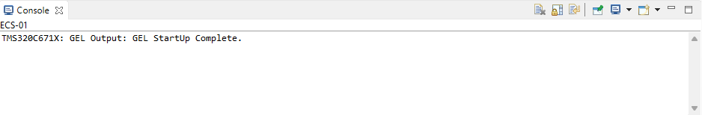

**Discussion or Inference of the experiment:**

In this experiment , we used a DSP processor kit ( DSK-TMSC6713 processor kit ) for implementing FIR/IIR filters in real time , measure system's responsiveness by examining the

latency between input and output signals Our analysis was centered on the DSK-TMSC6713's computational efficiency when running FIR/IIR.We used an audio file from the system and used FIR /IIR filters on it and also used audio output device to analyse the output signal.We scripted the code in C programming Language.

**Conslusion:**

This experiment taught us how to use setup a DSP processor kit (DSK-TMSC6713) , connect the kit to the computer and run code on the hardware using CCS , execute FIR/IIR filters in real-time using the DSKTMSC6713 processor kit , use external files( here audio) n the DSP processor kit and operate on them. We learnt about the nature and function of the FIR/IIR filters and their effeciency , and problems regarding them on a DSP processor.